1. Robots with 4 legs are called?
A. Biped B. Hexapod C. Quadruped D. Uniped

2. Atmega324 has how many pins?
A. 32 B. 28 C. 40 D. 38

3. Bit wise AND operation is performed using
A. | operator B. || operator C. & operator D. && operator

4. ISR stands for
A. Internal Status Register B. Interrupt Status Register
C. Interrupt Service Routine D. Internal Service Register

5. Which of the following gate will provide logical multiplication of two inputs?
A. NOT B. OR C. NAND D. AND

6. In NTC thermistor, the temperature ________________ when its resistance decreases.
A. decreases B. increases C. remains the same D. fluctuates

7. USART stands for
A. Universal Synchronous/Asynchronous Receiver/Transmitter
B. Universal Synchronous/Asynchronous Radio Transmitter
C. Universal Synchronous Antenna Radio Transmitter
D. User Specified Asynchronous Radio Transmitter

8. In common cathode SSD, the common pin is connected to ________.
A. Vcc B. Ground C. RX Pin D. No where

9. Atmega 32 is _____ bit microcontroller?
A. 16 B. 8 C. 28 D. 40

10. Atmega324 has ____ ADC channels
A. 8 B. 32 C. 2 D. 6

11. LCD stands for
A. Liquid clear display B. Liquid crystal display
C. Line clear display D. Line crystal display

12. Which of the following keyword is used to create function in a program?
A. void B. int C. float D.for

13. Which register is used to enable Global interrupt?
A. SREG B. TMSK1 C. UCSRA D. Both A and C

14. In a biped, if the robot has to take a left turn,
A. Both legs must move in the forward direction.
B. Both legs must move in the reverse direction.
C. Only left leg must move in the forward direction.
D. Only right leg must move in the forward direction.

15. delay_us(10000) will create a delay of ___?
A. 10 seconds B. 10 ms C. 10 us D. 100 us

16. Analyse the circuits and write the output for the LED in the following tables.

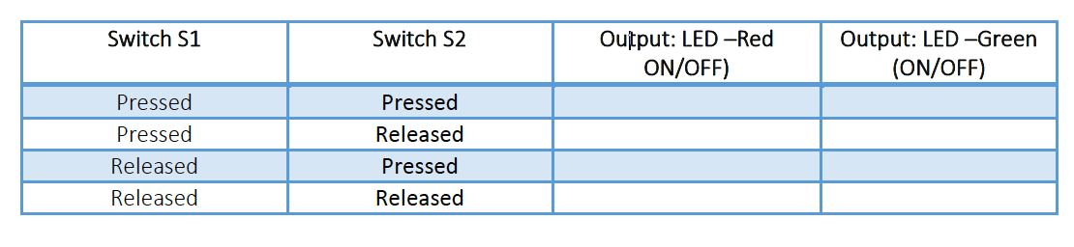

17. Analyse the circuits and write the output for the LED in the following tables.

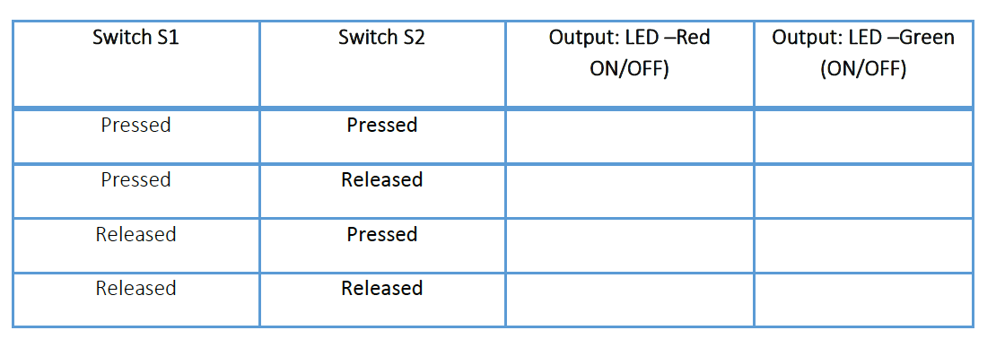

18. Match the following:

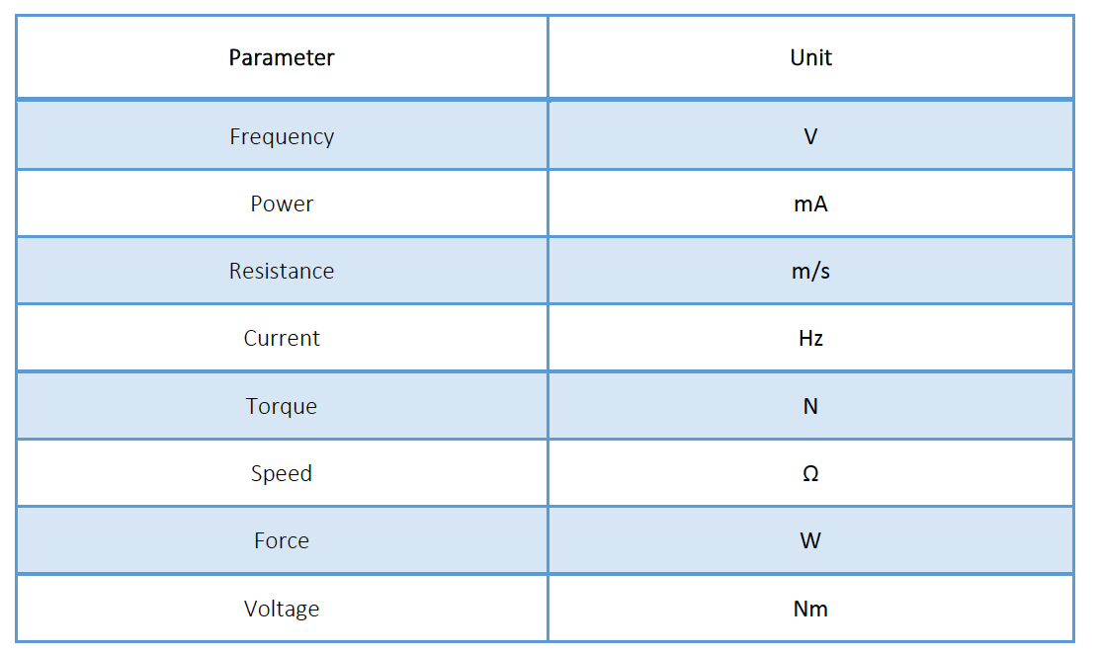

Practical:

- Create a Dot Matrix to display your names

- Make a Quadruped using 4 servo motors. Make the Quadruped move forward and backwards in intervals of 5 seconds – 5 seconds forward and 5 seconds backwards

